2017-2018 PRE-HEALTH PEER MENTORS
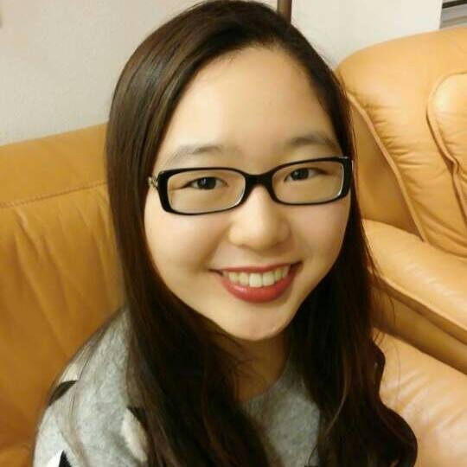
Co-Director: Edel Auh

Hello! My name is Edel, and I’m one of the Co-Directors for the Pre-Health Mentor Corps this year!! I am an ‘18 Comparative Literature major specializing in Japanese Translation and a Japanese and Anthropology in Global Health double minor. During my time at Dartmouth, I’ve been on a LSA+, studied abroad at Keio University, and done a computational biology internship - all in Japan! I’m currently involved in Dartmouth EMS and am a certified NREMT and a Basic Life Support Instructor. I have worked in the Tomlinson Lab at the Cancer Center as a Sophomore Scholar and a James O. Freeman Presidential Scholar, researching protein pathways that lead to obesity and having way too much fun with mice. My other key activities on campus include being one of the Dartmouth Cancer Scholars Directors, being a part of the Committee on Standards with the Office of Judicial Affairs, and acting as one of the Deans’ Office Student Consultants for this year. Next year, I will be entering Geisel School of Medicine as a member of the Class of 2022!
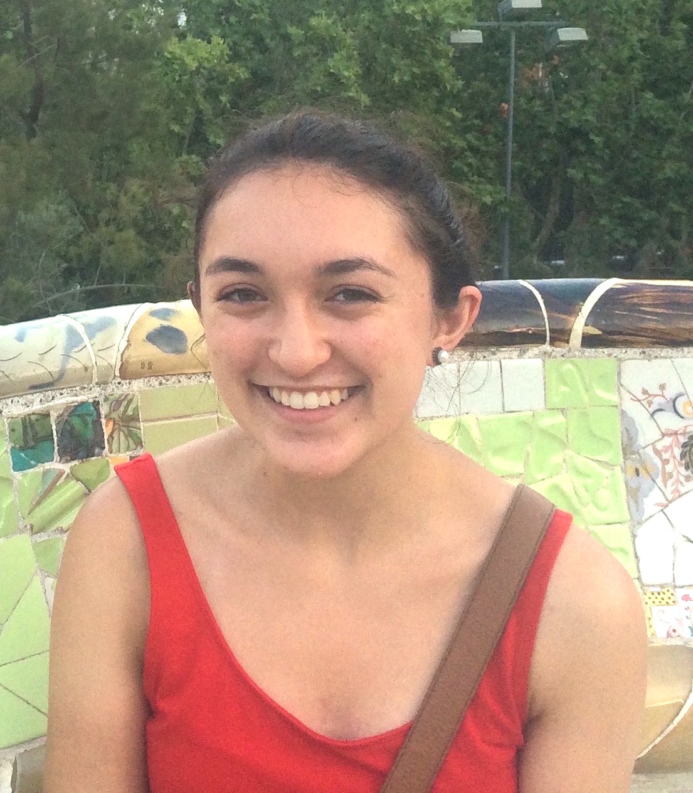

Co-Director: Sumita Strander

Hi! My name is Sumita, and I'm so excited to be one of the Co-Directors for the Pre-Health Mentor Corps this year! I am an '18 from Albion, Michigan, majoring in Anthropology-modified-with-Neuroscience. On campus, I am currently a Stamps scholar working on a project/senior thesis on dementia care for Indian elders, and have worked in the past in a few other labs at Thayer. I am involved with a few global health groups, the Dartmouth Undergraduate Journal of Science, and I work as a study group leader and as a tour guide. I also volunteer as a tutor and with community members living with dementia. Away from Dartmouth, I had a wonderful experience studying abroad in Santander, Spain on a Spanish LSA+, and I spent my off-terms working with elders at the University of Michigan hospital and doing research at Dartmouth and in India. In my free time, I love watching films (especially at the Telluride event on campus!) and trying new restaurants/foods. Feel free to contact me anytime at sumita.m.strander.18@dartmouth.edu!

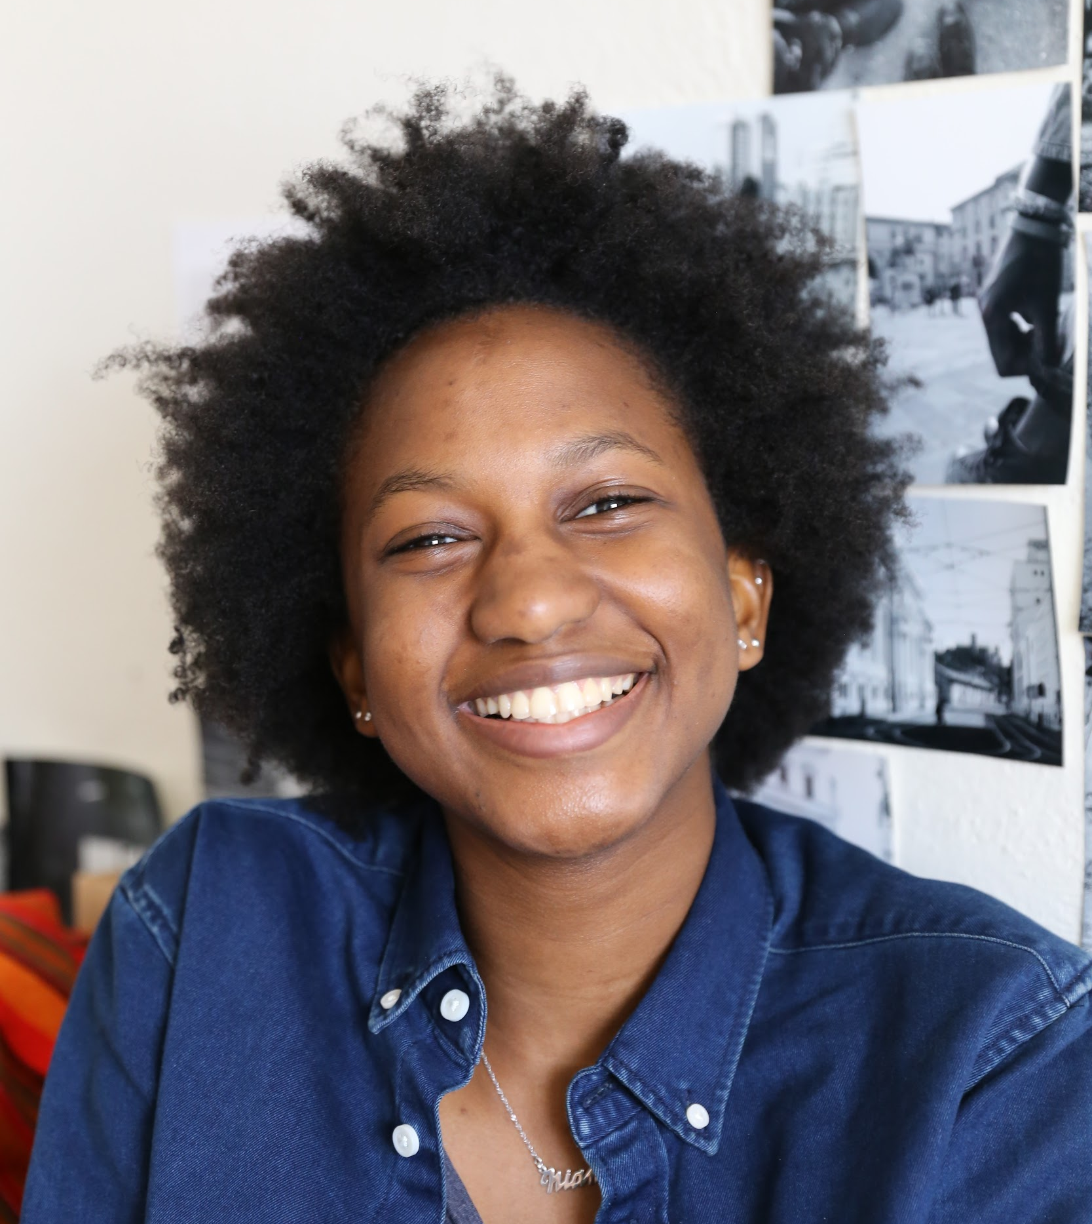
Niamé Daffe

Hi! My name is Niamé. I’m an’18 from Mali and Swaziland. I am double majoring in Biology and Sociology with the intention of pursuing a career in public health. On campus, I am a Global Health Fellow, I dance with Soyeya African Dance Troupe, I work at the Rockefeller Center where I do database management and I am an intern for Pathways to Medicine. I have also been involved with the African community on campus through DASA and the Afro Diaspora LLC. During my off terms, I have shadowed a lab technician at a local hospital in Swaziland, I worked as an intern at the Academic Skills Center on campus and most recently I did a global health internship in Tanzania regarding TB and HIV research. I really enjoy having long conversations, reading and watching Netflix and my favorite beverage is tea.

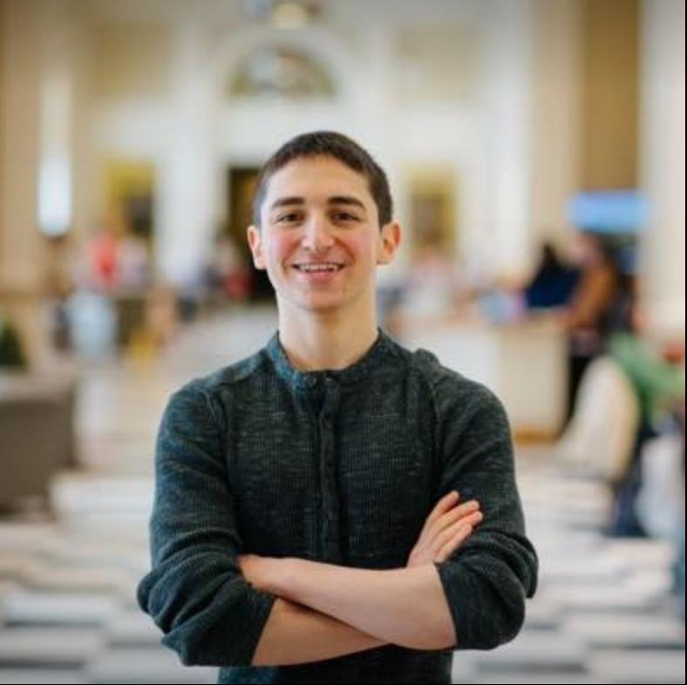
Nicholas Norwitz

My name is Nicholas Norwitz, and I am a cell biology major from Newton, MA. On campus, I am the biology Resident Expert for School House, a biology and chemistry tutor, a research assistant in the lab of Professor Sharon E. Bickel, participates in the Nathan Smith Society, serves as the undergraduate representative for Dartmouth’s Council on the Libraries, and enjoys swimming and biking. I plan to pursue graduate level research in the UK and/or an MD/PhD program following graduation. From shark diving to sky diving to climbing waterfalls to crutching marathons, I always say yes to new adventures or challenges and try to live by the motto “When you make every experience is a lesson, life becomes your classroom.”

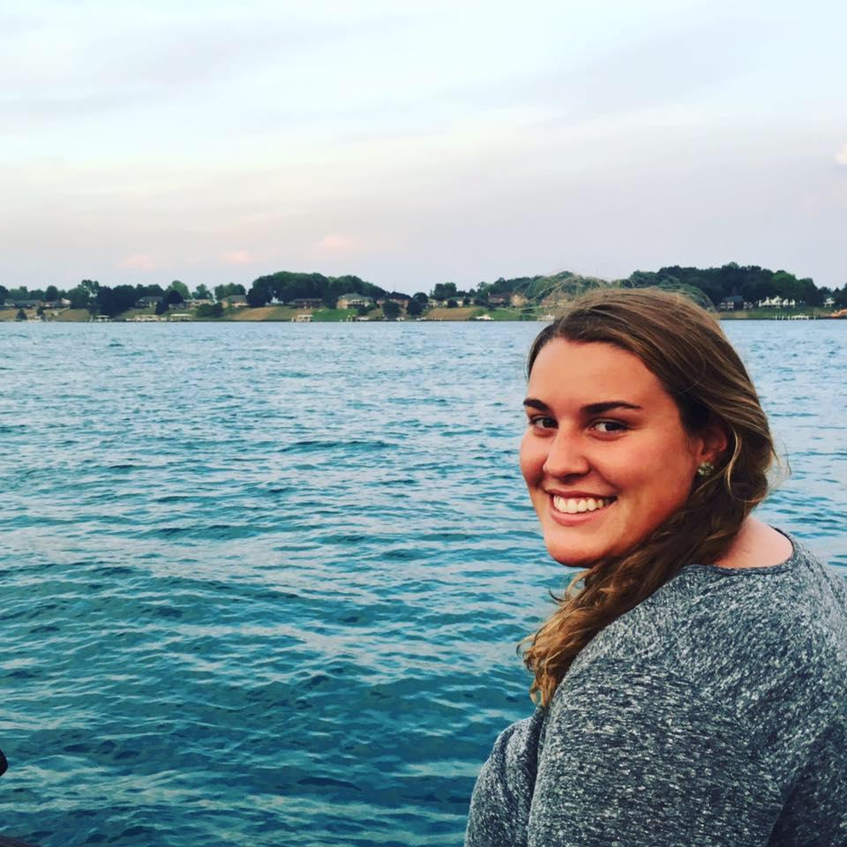
Miranda Greig

Hi! My name is Miranda Greig and I am a ’19 from St. Clair, Michigan, majoring in Biology with a concentration in Molecular Genetics. Outside of the classroom, I am a research assistant in Professor Sharon Bickel’s lab in the Biology department. In addition to lab, I am also involved in many volunteer programs at Dartmouth including Volunteers for Cancer Patients (VCP), Maynard House Visits, and ASPIRE. I am also a tutor through the Academic Skills Center and am an active participant in the shadowing program through Dartmouth’s Nathan Smith Society. When not studying or in lab, you can be sure to find me playing tennis and hanging out with friends, exploring the Upper Valley, reading a book at some of my favorite places on campus, or shamelessly watching Grey’s Anatomy. I would absolutely love to personally get to know you over coffee or a meal! Please do not hesitate to reach me at Miranda.M.Greig.19@Dartmouth.edu. I look forward to meeting you!

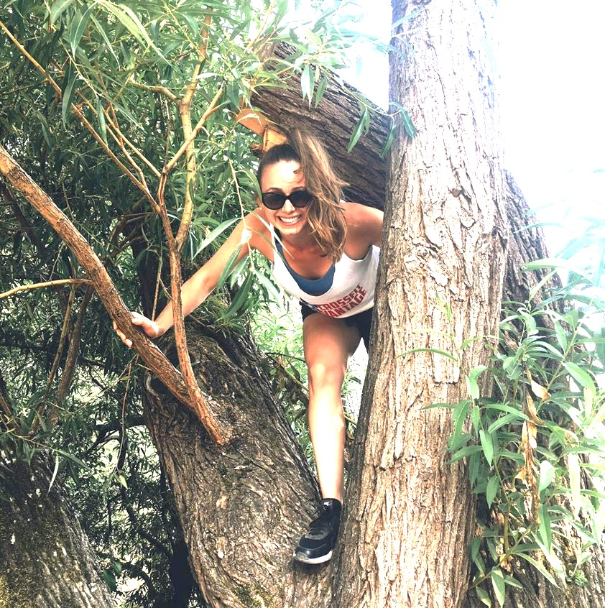
Kaija Stern

My name is Kaija Stern and I am an ’18 from Seattle. I am majoring in Hispanic Studies and minoring in Global Health while on the premed track. During my off terms, I have participated in immunology research at DHMC, where I studied the effects of Influenza A virus on pulmonary mast cells in the Obar lab. I have also worked as a Spanish-English translator and clinic assistant at a medical clinic in Santa Cruz la Laguna, Guatemala, as well as worked as a children’s residential intern at Navos, a non-profit in Seattle that provides holistic care to children in the foster care system that have undergone serious abuse and trauma. At Dartmouth, I work as a Spanish tutor as well as a DartFIT instructor at the gym on campus. In my free time, I do Crossfit and enjoy hiking, kayaking, cooking, and my dog Charlie.

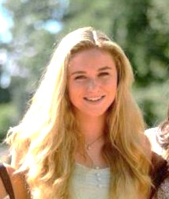
Charlotte Berry

Hello! My name is Charlotte and I am a ‘19 at Dartmouth. I am currently working on a Global Health major and Biology minor. I am from Rochester, Minnesota where my family lives on a small family farm with chickens and three dogs. On campus I am a member of Dartmouth EMS, DUJS, a first aid and CPR instructor, and a Global Health Fellow. I am currently conducting research on two teams at DHMC as well as a Presidential Scholars assistantship. I have travelled to Nicaragua with a global health trip in the past and plan to return in December 2017. In my spare time, I love to run and I am very interested in digital design!

Amelia Ashley

Hello! My name is Amelia Ashley and I’m an ‘18 Cell Biology major from Gretna, Nebraska. I am an enrolled member of the Crow Creek Sioux Tribe, but was raised as an Umo^{n} ho^{n} wa'u (Omaha woman), which is a tribe in northeastern Nebraska. On campus, I work as a research assistant in the Space Medicine Lab at DHMC, and as an undergrad TA for Bio 46 (Microbiology). I’m also a member of the American Indian Science and Engineering Society (AISES) and APiO. Most of my academic and personal interests revolve around Native American health, and my goal is to go back and serve as a physician in my community someday. My favorite pastimes include cooking (and eating what I cook), beading, listening to music, and taking short hikes on the trails around campus. If you have any questions or just want to talk, feel free to email me at amelia.e.ashley.18@dartmouth.edu. I would love to get to know you!

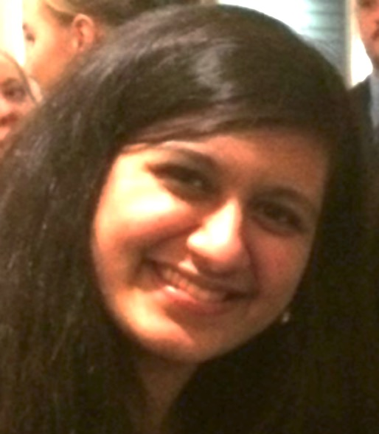
Sadhana Puri

My name is Sadhana, and I am a Biology major and Theater minor from New Orleans, Louisiana. I have conducted research in the areas of women’s health, microbiology, immunology, and health policy. I am a volunteer for Patient Support Corps and enjoy playing an active role in the shared decision making process. I also enjoy helping my peers as a tutor for Organic Chemistry and am currently a TA for ENGS 13: Virtual Medicine and Cybercare. In addition to my scientific and medical interests, I am involved in theater at Dartmouth in the realms of acting and playwriting. This past summer, I got to explore my interest even further while on the Theater FSP in London. I am passionate about combining my interests in medicine and theater and hopes to create a performance piece focused on the patient experience. Also, I will be attending Geisel School of Medicine through the Early Assurance Program.

Kevin Hoffer-Hawlik

My name is Kevin Hoffer-Hawlik. I’m a ’19 Biomedical Engineer from Miami, FL and have 3 siblings, one currently at Columbia Med. I am a brother of Tri-Kappa Fraternity, I play midfield on the Club Lacrosse team, I sing tenor with the Glee Club, and I’m a CS1 Section Leader. I shadow at the DHMC in plastic surgery, and I perform research in Optics in Medicine for the Pogue lab. As a James O. Freeman Presidential Scholar, my current research studies the use of biomedical imaging using antibodies to fluoresce tumors during and after resection. In my free time I play piano (which I’ve played since I was 4), practice singing, and play pickup basketball at the gym. I’m interested in improving patient care through research in drug delivery and tissue engineering, as well as providing pediatric care to all of those in need, especially those who are from underprivileged areas.

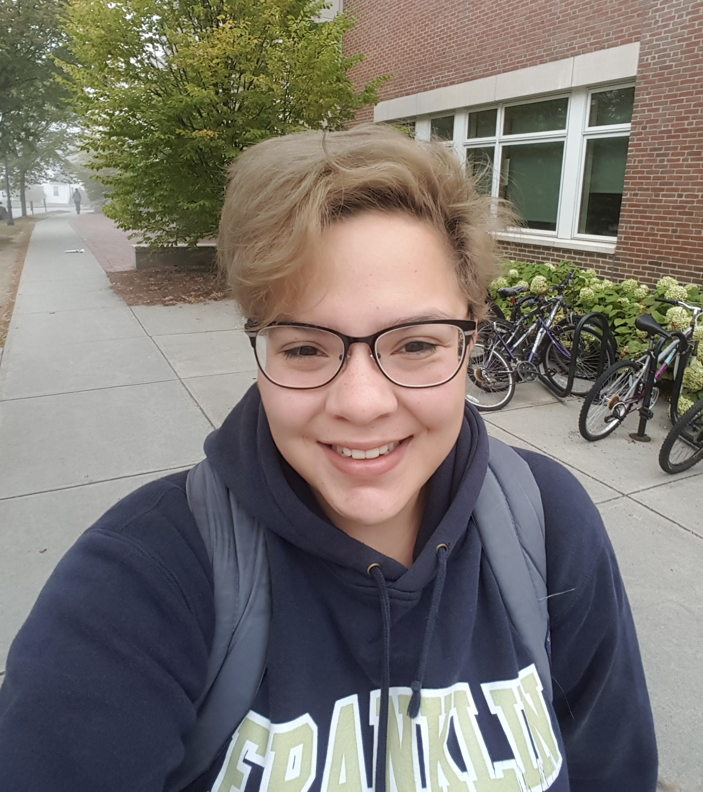
Francine Mejia

Hello! My name is Francine Mejia. I am an '18 from Los Angeles, California. I'm a biology major with a concentration in Human Biology. I am a pre-Medicine student. Funny enough all of my research experience has been in Ecology, where I helped to study the effect of rising mercury levels on local crayfish. My most exciting off term experiences have been the summer of my freshman year when I was able to participate in a program call Summer Medical and Dental Education Program (SMDEP) at UCLA and this past summer, my junior summer where I was able to participate as an Health Career Connections intern in the Eisner Health Center's Quality Improvement department. Both of these programs are amazing! I also love to volunteer. Over the summer I was able to volunteer in the Labor and Delivery department of the Huntington Memorial hospital. On campus I like to volunteer my time bring food to the Upper Valley Haven with Dartmouth Feeding Neighbors and help play cognitive and social development games with children on the autism spectrum with Aspire. My more social activities include participating in my Gender Inclusive Greek house, Alpha Theta, where I am the current Vice President and the representative for the Gender Inclusive Greek Council.

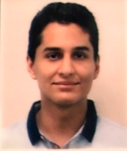
Armin Tavakkoli

Hi. My name is Armin, I love my failure stories more than my successes, and I do not believe in impossible. I moved to New York alone at the age of 12 to follow my passion of studying medicine. While you will often hear me talk about my experience going through high school and my freshman year at Dartmouth, there is a major disclaimer that I need to mention: Had it not been for the guidance of my teachers and tutors, I would not be standing where I am today, both academically and otherwise. So without any further ado I look forward sharing my experience and knowledge with those that have dreams and aspirations that seem "impossible", and work to prove them possible.

Marcus Gresham

Hi! I'm Marcus Gresham, an '18, majoring in Sociology. I am involved in the Pathways to Medicine Program, NAACP, and the Afro-American Society. The coolest health opportunity that I've done thus far has been planning a health fair for Black men in Atlanta. I also spent two off terms doing research, one at Massachusetts General Hospital/Brigham and Women’s Hospital and another at New York-Presbyterian WCMC. For fun, I enjoy playing basketball spades. Fun fact: I DJ.

Emily Husson

Hi! My name is Emily and I'm from Franconia, NH. I just graduated from Dartmouth in 2017 where I was a History major. In my time at Dartmouth, I was on the Women's Alpine Ski Team, a Latin tutor, in OLE, a part of Patient Support Corps at DHMC, a member of Kappa Delta Epsilon, and a Student Assistant at the Ceramics Studio in the Hop. I was also a Sophomore Science Scholar where I combined my interests in history and medicine by working on a project that utilized Hanover’s historical death records. During my off term, I went to Colorado and interned at a podiatrist clinic and simultaneously got my skiing fix in. Presently, I am taking a Gap year and applying to medical schools. I am working at DHMC as a Research Coordinator in the Department of Orthopaedics. When I’m not working, you can likely find me on a mountain, either hiking up or skiing down. Feel free to contact me about anything(!) at Emily.G.Husson@Dartmouth.edu.

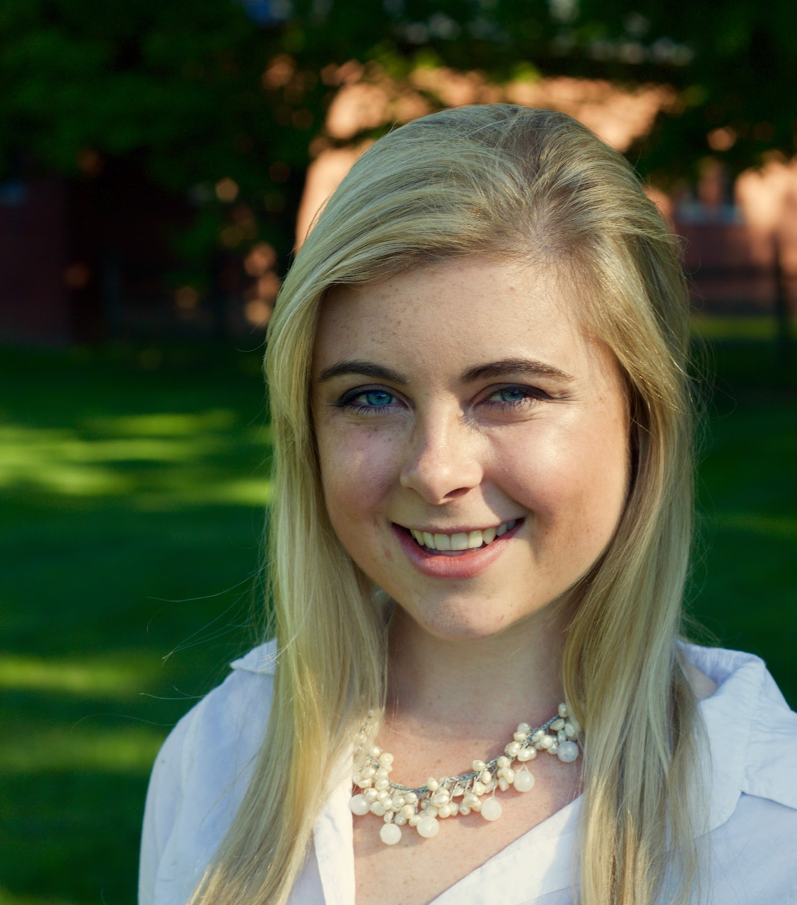
Caroline Braun

My name is Cally, and I am an '18 from the small town of Charlotte, Vermont. While I have always been pre-med, my major hasn't been as constant; recently, I switched to Anthropology modified with Global Health from Neuroscience. I am also an Ethics in Biomedicine minor. Although I have not studied abroad, I spent my summer immersed in the life of a rural Ugandan village doing a global health internship with the Uganda Village Project, a nonprofit. Right before school started, I was able to squeeze in an a class at NOLS in Wyoming to obtain my EMT, which I plan to use in my gap year. On campus, I am also a tour guide for the Admissions Office, a member and previous co-coordinator of the Nathan Smith Society, a Global Health Fellow through the Dickey Center, a member of Alpha Xi Delta, and a founder of Generation Action at Dartmouth. Off-campus, I volunteer in the Emergency Department at DHMC and, when possible, with Planned Parenthood. For three years, I was on the Varsity Nordic Ski Team here, but decided to stop for my senior year so that I have time to explore my other interests. However, I still love skiing and most outdoor activities, whether it be running, biking, hiking, or fall leaf-collecting. Please let me know if you have any questions!

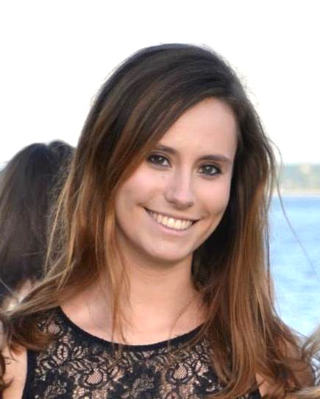
Manon de Villemejane

My name is Mannie de Villemejane. I’ve been interested in medicine since I was a little kid! I just recently finished my pre-med requirements and have taken my MCAT. On campus I am the Director of Operations of Dartmouth EMS – I really love serving and helping the Dartmouth community through this organization. I also volunteer at DHMC as part of the Art-cart program. I have been doing neuroscience research since winter 2016, specifically with facial perception. I hope my experience with the pre-med course and my activities will be able to be helpful for other students on the pre-health track.

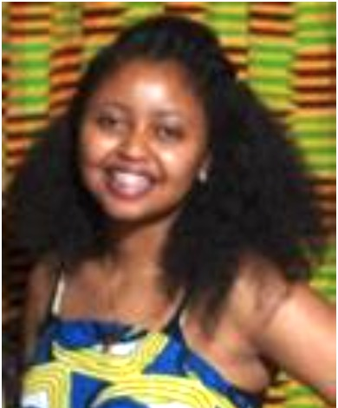
Enat Arega

My name is Enat Arega and I am an '18 from Addis Ababa, Ethiopia, although I currently reside in Seattle, Washington. I am majoring in Biological Sciences and minoring in African Studies. At Dartmouth, I have been involved with Dickey Center, WISP/research, DASA, and Soyeya African Dance Troupe. In my free time, I like to think, to listen to podcasts, and to spend time with friends and family. If you have any questions, please feel free to reach out!

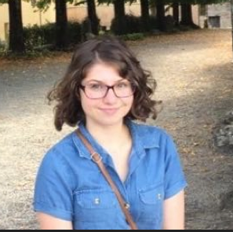
Angelina Lionetta

Hello there! My name is Angelina (but you can call me Angie) and I'm an '18 from Andover, MA. I'm majoring in Classical Archaeology and also completing the Global Health Certificate through the Dickey Center. On campus I'm involved with a few things. I am a Dean’s Office Student Consultant (DOSC), a member of chi delta, I was a SEAD mentor my sophomore summer, and I'm the social chair at Aquinas House (the Catholic Student Center), where I also do weekly volunteer work. I studied abroad during 15F on the Classics FSP to Rome where I spent ten weeks climbing through catacombs/tombs/other cool old things, so if you ever want to discuss the Romans and/or early Christianity, I'm your girl. For fun I love doing outdoor activities with my friends like running, hiking, canoeing, and swimming, but I also love ice cream and chocolate, so it all balances out. I'm a pretty avid bookworm, particularly sci-fi so definitely get in touch if you want to geek out over something cool. As far as med school and later life goes I know that I want to become a neonatologist, I spent the last 6 months volunteering in the ICN at DHMC. My little brother has autism, so I'm very active in the special needs community! If you ever have a question or want to talk, I love hanging out on the green and/or getting coffee at Dirt, so feel free to contact me any time at Angelina.E.Lionetta.18@dartmouth.edu.

