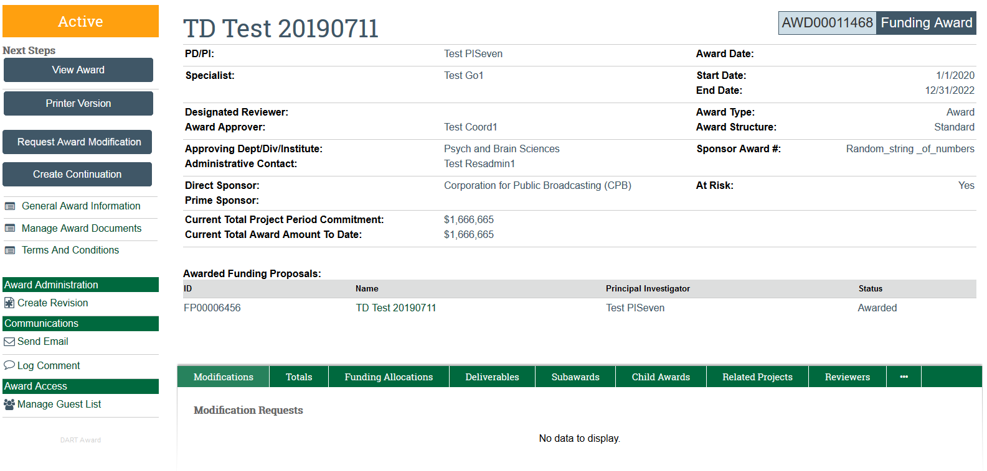
WHAT’S NEW!
Role names have changed: Specialist = Grant Officer Award Approver = SRM Admin Contact = DRA Dept/Div = Submitting Dept
“At Risk” flag: When an advance account is setup “At Risk” will be marked ‘Yes’. SRM changes the status to ‘No’ when the Notice of Award is received and the PTA is active by using the “Update At Risk Status” activity.
Request Award Modification: The DRA uses this activity to submit a request to the OSP SRM (No cost extension, Rebudget, Carryover, Budget Alloc Correction, Closeout, Early Termination, Personnel Change, Other). See training documents for more guidance.
Deliverables: Deliverables that should be tracked are Financial Reports, Invention Reports, Property Reports, Other Closeout Reports that OSP is responsible for, Labor Verification Reports, Miscellaneous OSP reports as required by the sponsor per the NOA.
Send Email: You are able to communicate within the RAPPORT Award record. This is for email/correspondence that is to be kept within the official file. Generic email questions can be sent through Outlook email.
Terms and Conditions: OSP SRM will continue to highlight the applicable terms and conditions that are listed in the Notice of Award.

