Awards – Search & Filter
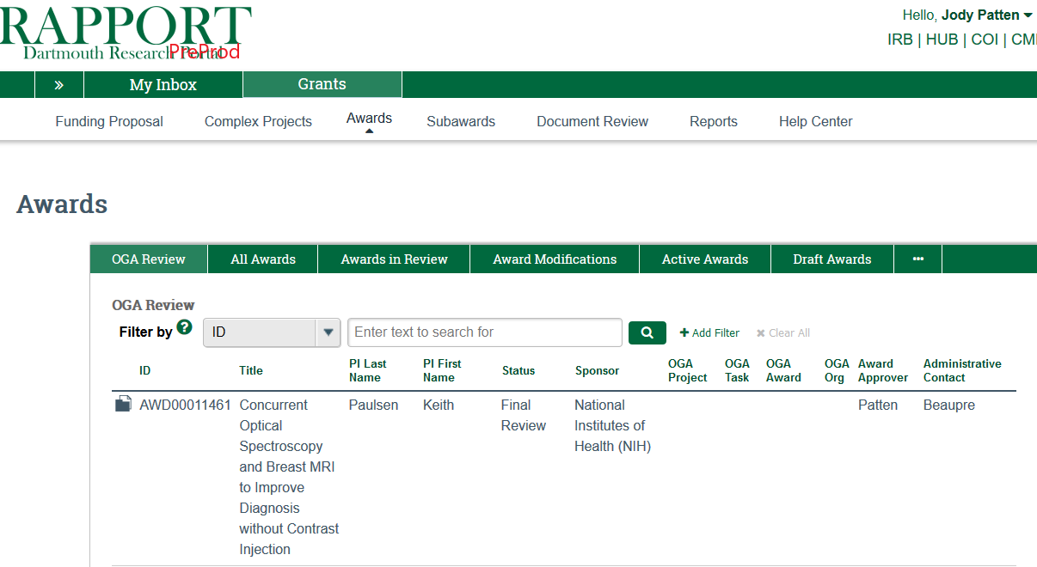
4
3
2
1
- Awards - List of Awards that you can search and sort by
  - click Grants
  - click Awards

- View Awards – Choose the appropriate tab of how you would like to see the Awards displayed
  - OGA review
  - All Awards
  - Awards in Review
  - Award Modifications
  - Active Awards
  - Draft Award
  - Subaward

- “Filter by” depends on the tab of Awards you are in.
OGA Review | All Awards | Awards in Review | Award Mods | Active Awards | Draft Awards | Subawards
ID | ID | ID | ID | ID | ID | ID
Title | Title | Title | Title | Title | Title | Name
PI Last Name | PI Last Name | PI Last Name | PI (Last Name) | PI Last Name | PI Last Name | State
PI First Name | PI First Name | State | State | Sponsor | State | Dartmouth PI
Status | State | Sponsor | Sponsor | Sponsor Award ID | Sponsor | Direct Sponsor
Sponsor | Sponsor | Specialist | OGA Project | Start Date | Award Approver | Subrecipient
OGA Project | Sponsor Award ID | Award Approver | OGA Award | End Date | Admin Contact | Award Segment
OGA Task | Start Date | Admin Contact | Sponsor Award ID | Award Approver | Specialist | Date Modified
OGA Award | End Date |  | Award Approver | Admin Contact
OGA Org | Award Approver |  | Date Modified | Specialist
Award Approver | Admin Contact
Admin Contact
- CLICK to enter the Award

