**Request Award Modification – DGM Initiates**

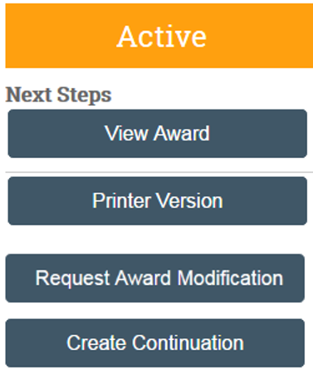

Select “Request Award Modification” Activity

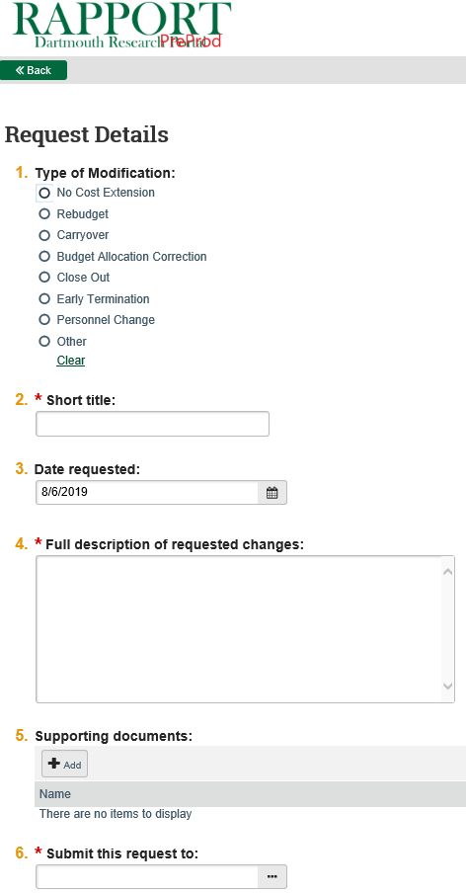

Select the type of Modification request you are submitting.

The name of the OSP SRM who this request should be submitted to.

Upload any supporting docs (i.e., email from PI confirming their request for the NCE.

See Page 2 for required documentation of each request type.

Click Finish – you will return to the main workspace

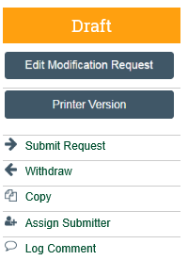

Your request will remain in DRAFT until you click “Submit Request”. You also have the option of withdrawing the request.

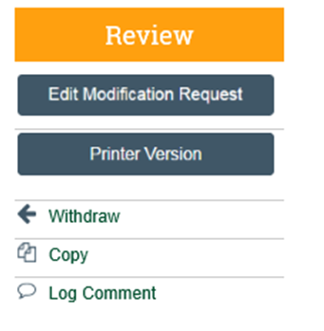

Once successfully submitted to OSP, the status of your Modification request should say “Review”. You have the option of withdrawing the request by clicking “Withdraw”.

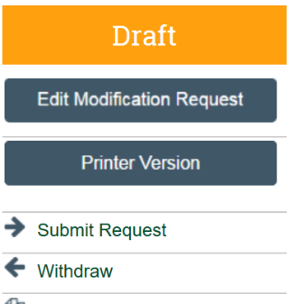**Request Award Modification Documentation**

**No Cost Extensions**

* **NCE requires sponsor prior approval**: DGM to upload PI signed request letter. OSP to countersign and submit to Sponsor.
* **NCE does not require sponsor prior approval**: When OSP is allowed to approve a one-time NCE of 12 months or less, the DGM should provide the PIs justification and extension details in the description box.
* No OSP internal NCE form necessary
* No PI signature required
* The RAPPORT Award Request is the ‘form’

**Rebudgets**

* **Rebudget request requires sponsor prior approval:**
  + Upload the request letter signed by the PI and submit to the SRM for review/countersign/submission to the Sponsor.
* **Rebudget request does not require sponsor prior approval**:
  + DGM to use the Comment box within the request for simple rebudgets (i.e., move $10,000 from Equip to Supplies), no need to use the budget template.
  + For complex rebudgets, DGM to use the upload supporting documents (i.e., budget template or any budget format used by the DGM).

**Carryover**

* **Carryover request requires sponsor prior approval:**
  + Complete letter from PI to sponsor to request the carryover from year to year.  Provide adequate justification of the request.  OSP countersigns this request prior to the SRM submitting the letter to the sponsor for consideration.
  + DGM uploads letter (and supporting docs required by Sponsor) in RAPPORT “Request Award Mod – Carryover”; submits to SRM.
  + Carryover dollars will NOT be moved in RAPPORT funding allocations among the years associated to this request.

**CLOSEOUT**

* **DGM completes their final figure statement in text box:** If any pending transactions (DB/CR) the backup docs can be uploaded and submit to SRM.

**EARLY TERMINATION**

* **Early termination by Sponsor:** If the sponsor contacts the PI/DGM about terminating the award early, upload the sponsor documentation and submit to SRM.

* **PI transfer out of Dartmouth:** Provide the PIs effective transfer out date and an interim final figure statement. Refer to the OSP guide ([https://www.dartmouth.edu/osp/resources/transfer.pdf](https://www.dartmouth.edu/~osp/resources/transfer.pdf)), depending on sponsor other items might be necessary so you should consult with your SRM. Upload any documents in request and submit to SRM.

**Personnel Change**

* **Personnel Change requires sponsor prior approval:** Letter should be uploaded in the Request within RAPPORT, signed by PI.  SRM should review/countersign/submit request to Sponsor.
* **Personnel Change does not require sponsor prior approval**: DGM to use the Comment box within the request. Upload any relevant documentation (i.e., email backup).

**OTHER**

***Example Scenarios*:**  New Subcontract not previously listed in FP. Any prior approval (foreign travel prior approval, change in effort, any change in subs (+/-) mid project year that are not part of the annual budget allocations from NOAs, or any prior approval not in the Mod Request list).

* Use comment field within Request Mod to communicate desired changes/prior approval.  Upload any prior approval letters required by sponsor.