**Request Advance Account – DGM Initiates**

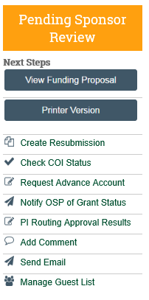

Activity “Request Advance Account”

Status should be “Pending Sponsor Review”

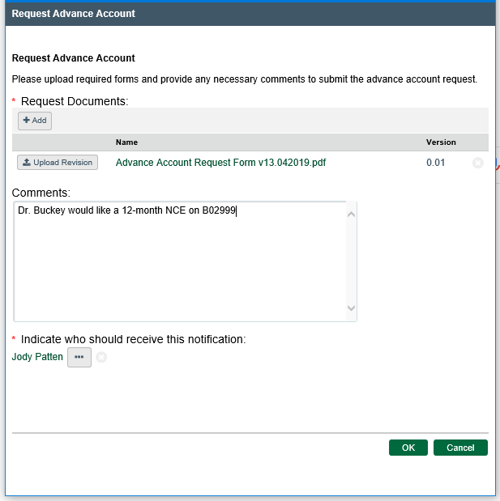

Enter the OSP SRM name you wish to send this request to.

Click OK

If you have other information to add to the context of the request, add “comments” in the text box.

Prepare the “Request for Advance Account or Pre-Award Costs” form. Upload a copy.

**Request Advance Account – SRM Receives from DGM**

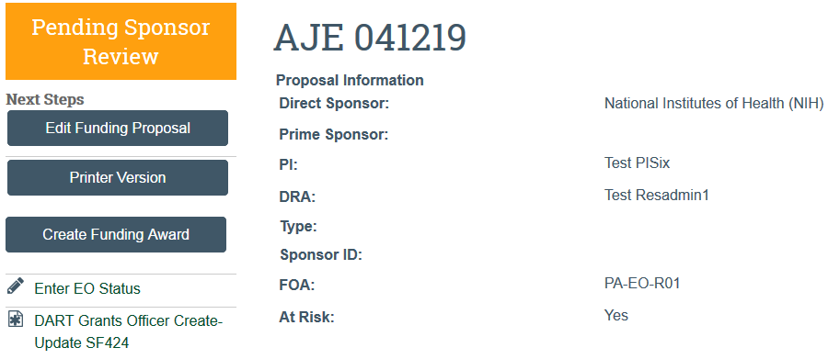

When an advance account is requested, the Funding Proposal ‘At Risk’ flag switches to “YES”

Receive an Outlook email notification of this request.

Setup the advance account in OGA.

“Add Comment” within the RAPPORT Funding Proposal to document the advance account setup.