**Budget Reconciliation – Ancillary Review – SRM Initiated**

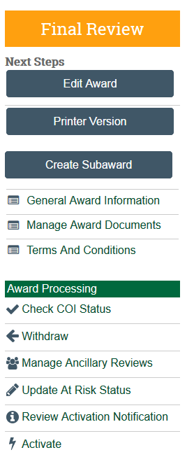

Draft Budget entered in Budget Reconciliation – SAVE & Exit

“Manage Ancillary Review” Activity

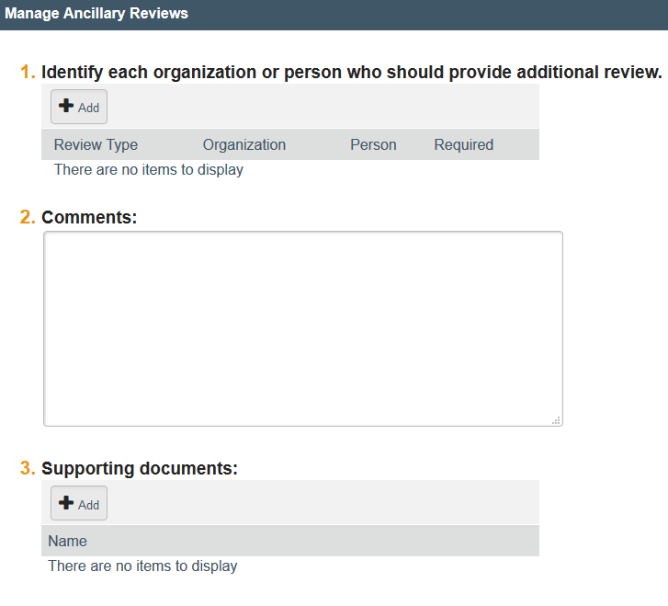

Click OK

Outlook email notification will be sent to DGM.

In Comments explain which budget allocation to review

Enter the DGM for who should review draft budget

**Budget Reconciliation – Ancillary Review – SRM Initiated**

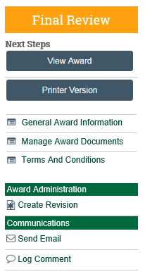

**NEW AWARD**

DGM enters “View Award”

From Jump To menu – choose “Budget Reconciliation”

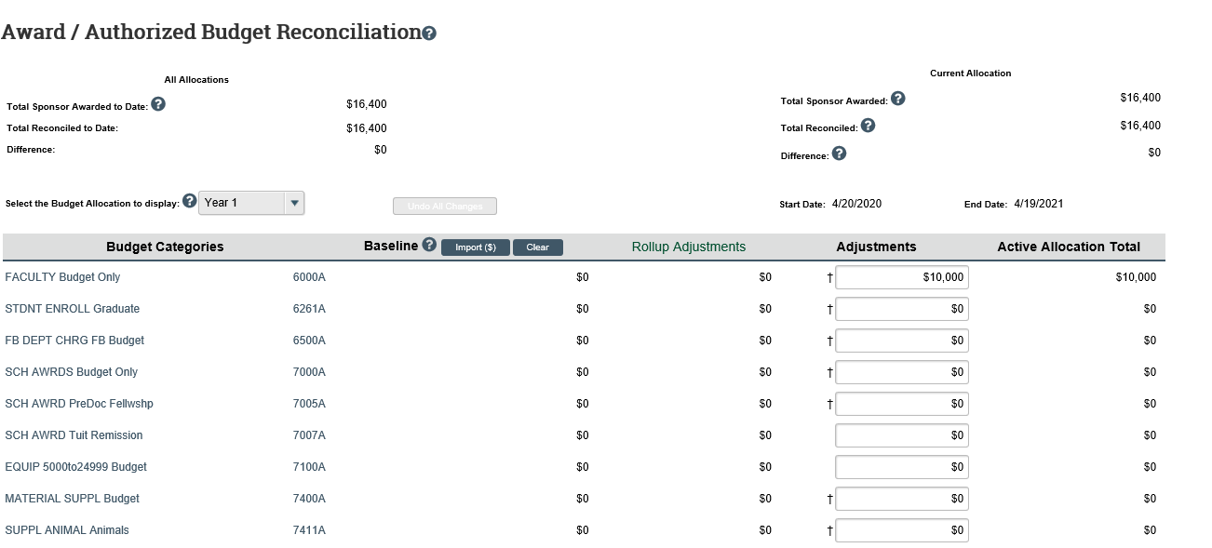

Review the Adjustment column for accuracy of budget input

Choose appropriate Budget Allocation needing your review

Budgets should be entered at the level roll up exp type per the FP and/or NOA

**Budget Reconciliation – Ancillary Review – SRM Initiated**

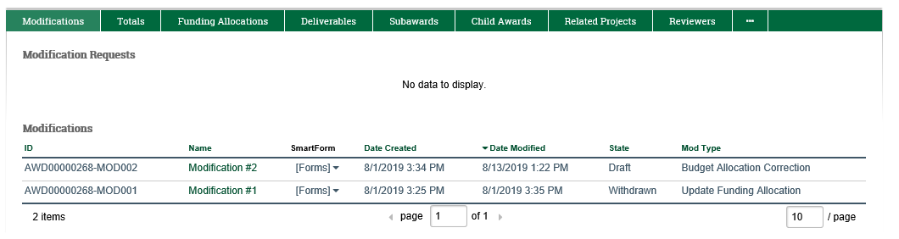

**MOD AWARD**

DGM enters “Award Mod”

Choose “Edit Award Mod”

From Jump To menu – choose “Budget Reconciliation”



Choose appropriate Budget Allocation needing your review

Budgets should be entered at the level roll up exp type per the FP and/or NOA

Review the Adjustment column for accuracy of budget input