Dartmouth College Library

Acquisitions Services – Annual Report FY15

July 1, 2014 to June 30, 2015

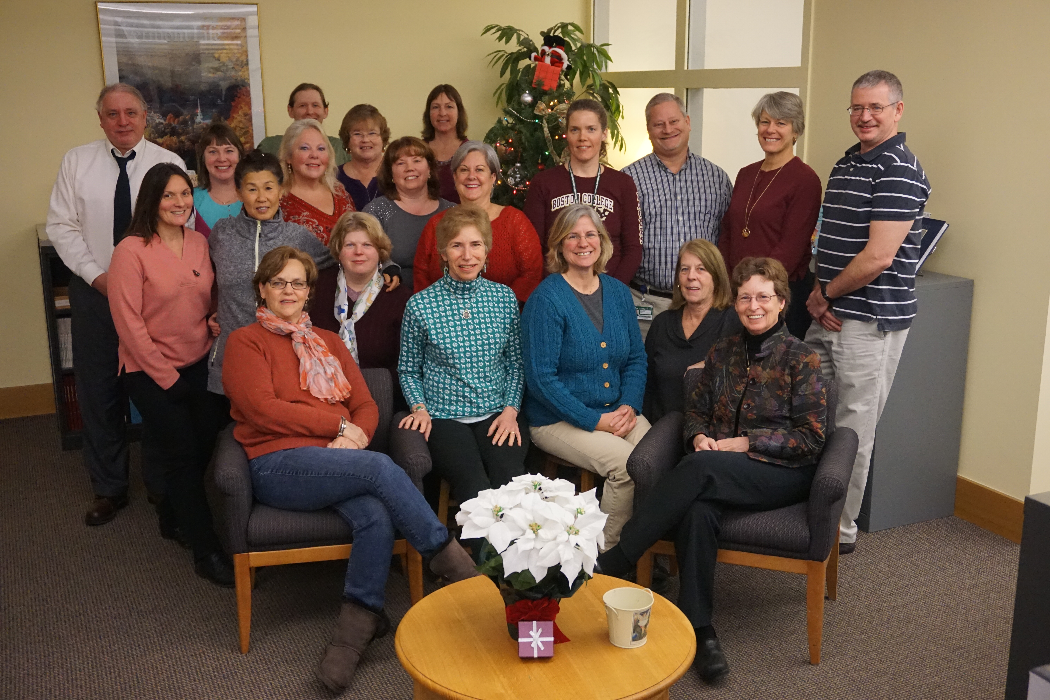

James Fein, Head of Acquisitions Services & Collection Assessment
August 14, 2015

Acquisition Services
Annual Report
Fiscal Year 2015

Executive Summary
Acquisitions Services advances the mission of the college through stewardship of the Library’s $9M+ Information Resources budget and other library expenditures that support scholarly content. The Department provides centralized services for all Dartmouth Libraries, and establishes and maintains excellent business relationships with vendors, publishers, and consortia worldwide to ensure timely receipt of quality material, generally at greatly discounted prices to maximize the College’s return on investment. The Department made significant contributions in FY14 in several key areas; examples are highlighted below.

Highlighted Activities

A year of staff changes
This year was marked by a number of staff changes in the department. James Fein’s former position of Collection Assessment & Analysis Librarian was eliminated as part of the plan to add two additional supervisors to the department in order for James to manage the responsibilities of being both the Head of Acquisitions Services & Collection Assessment. Two supervisors, promoted from within, were named in early April, Tim Wolfe and Becky Torrey. Shortly thereafter, both Jan Peltzer (Electronic Resources Specialist) and Jamie Dalton (Vendor Relations Specialist) resigned. The new Acquisitions Management Team (James Fein, Julie McIntyre, Kathy Walker, Becky Torrey and Tim Wolfe) decided to convert the Vendor Relations Specialist into an additional Electronic Resources Specialist based on the need for additional staff with specialized skills required for that aspect of departmental work. This also enabled us to hire two individuals for the two openings in one single round of recruitment. The two new Electronic Resources Specialists will begin in August and September. Karen Welch was promoted to Electronic Resources Specialist from Acquisitions Assistant, thereby creating another vacancy to fill in FY16.

HathiTrust Copyright Review Project
Acquisitions continues to make a valuable contribution with .33 FTE dedicated to the HathiTrust Copyright Review Project, a grant-sponsored project to make works in the public domain available to as many people as possible. Sixteen institutions participate in this phase of the project that currently runs through December 2016. Jan Peltzer had been one of our three staff members trained and contributing to this project. Goodie and Karla have increased the time they work on this project to continue to meet our commitment through the end of the current grant.

Bulk Purchases for the College
Acquisitions managed several special bulk purchases on behalf of Human Resources and the Dartmouth College Fund. Working with our primary English language vendor, Coutts/Ingram, we are able to receive deeply discounted pricing resulting in substantial savings to the College.

Alumni Memorial Book Fund (AMBF)
The Alumni Memorial Book Funds (AMBF) program assigned 366 memorial titles in the past fiscal year, spending a total of $19,534 of donated class funds. The Class of 1984 joined the program, bringing the total participating classes to 41. The Class of 1940 also provides a special annual donation, above and beyond their per-member memorials, which this year helped to supplement the biomedical library’s budget.

Dartmouth PhD Permissions
Additional steps were taken to transition Graduate PhD permissions tracking from the Digital Production staff to Acquisitions. Current workflow was reviewed and initial adjustments were made to test new processing procedures. The Graduate Office began sending permission forms directly to Acquisitions in June/July 2014.

Open Access Policy and DAC workflow planning
James Fein began meeting regularly with Barbara DeFelice to begin discussing probable Acquisitions Department staff involvement in permissions and other workflows emerging as a result of the Open Access Policy being adopted by Arts & Sciences and the development of the Dartmouth Academic Commons. James joined the early DAC Content Working Group to determine which processes and workflows would make sense being handled by Acquisitions. Additional acquisitions staff members will be added to this group once the documenting of workflows and training needs are identified. Both Becky Torrey and Kathy Walker will joining this group in FY16.

Financial processes:
FY15 fiscal close was handled a bit differently this year than in the past. Placing orders was not halted in mid May, but allowed to continue into mid June. Approvals continued to be processed as well for extended time. Another change was to carry over FY14 budget fund allocations into FY15 rather than starting the new year with zero balances in all funds. The combination of these changes resulted in the least number of days with no ordering in the history of the department, only three business days. Once FY16 budget allocations were received, those funds that had no change in the allocation amount, did not require any manual changes, but only those that changed. This saved a lot of time manually inputting each allocation for each of the approximately 450 funds. It also resulted in the ability to begin paying invoices sooner than we had in the past also.

PACC SQL/API subgroup participation:
James Fein began serving on the PACC SQL/API subgroup to represent the department in researching methods previously not available in Millennium, but now possible with Sierra. For Acquisitions, we are looking at alternatives ways to query information and statistics from the Sierra database that can replace “review files” which was the only option prior to Sierra. A number of test cases are currently being proposed to assess this opportunity.

Library Vendor Chaos:
This year also produced many unanticipated changes in large material vendors, from whom we purchase for the library. SWETS went bankrupt and ceased to exist. SWETS had been our largest supplier of print journals. Hundreds of journal subscriptions had to be ceased and re-ordered with other vendors (primarily Ebsco) in order to continue providing valuable resources to our patrons. Many staff members put in numerous hours as part of the Acquisitions triage task force. Another large vendor who we relied on for a large number of monograph standing orders, Book House, also went out of business. Similarly, another triage task force was created to re-order the many print volumes we previously had with Book House. The majority of these went to Midwest Library Service and some to Ebsco. As of this report, our largest print monograph vendor, COUTTS, was purchased by information giant Proquest. The department is anticipating further developments as a result of this change in FY16.

Statistics

- $19,534– received through the Alumni Memorial Books Program to offset collection dollars.
- $ 2,111.00 - commissions from Better World Books sales
- Total number of orders placed 26,752 (an average of 2,229 per month), a slight increase from FY14 by 1.5%

FY15 Library Expenditures

A&S | $7,515,113
Business & Engineering | $1,849,946
Medical Science | $1,327,099
Total | $10,692,148

Important Issues Looking Ahead

FY16 will be a year of transition and new service offerings. Formal training is being developed for new hires and a plan is in place to begin supplementing written work procedures with video tutorials for staff to refer to particularly for tasks they do not engage in regularly or certain tasks that are only required annually around fiscal close. The continued development of the DAC will flush out which workflows will come to Acquisitions and how that will impact the need for training and staffing.

Highlighted Goals and Initiatives for FY16:

- Transition Dartmouth PhD permissions tracking from Digital Productions to Acquisitions Services; train staff and create a records management policy.
- Research potential workflow and systems support for managing and tracking publisher permissions as part of the DAC.
- Contribute .33 FTE to the HathiTrust Copyright Review Project Phase II under current grant which expires December 2016.
- Expand the collection assessment and analysis training program by training Acquisition liaisons to create commonly requested review files; and provide advanced training to the Review File Team.
- Train new hires; recruit for an Acquisitions Assistant to replace Karen Welch.

Submitted on behalf of Acquisitions Services,
James Fein, Head of Acquisitions Services & Collection Assessment

Acquisitions Services
Acquisitions is responsible for ordering resources selected by twenty-seven library professionals across the library system, monitoring expenditures, and maintaining subscriptions and licenses for resources that the Library acquires over a long period of time. Digital resource acquisition and access requires additional licensing contracts, trial arrangements, extensive and complex price and terms negotiation, ongoing site administration, as well as immediate resolution of technical or contractual issues to ensure continued access for students, faculty, and administration. Acquisitions manages business processes in the Library’s Integrated Library Management System, assigns invoice payment to over 200 endowed and subvention funds, and exports invoices on a regular basis to the college’s Accounts Payable Department through electronic data exchange.

Acquisitions Services provides collection assessment and analysis services and prepares financial and collection statistical reports for Subject Specialists and the library administration, and prepares the annual statistical reports for external entities such as the American Research Libraries. Staff members also manage special programs such as the Alumni Memorial Books Program and Gift Books, and partners with Better World Books for resale of discarded library materials. The Department contributes .33 FTE to the HathiTrust Copyright Review as part of the Library’s membership in HathiTrust.

 | Acquisitions Staff FY15 | Hours | Title | Grade
1 | Braman, Alexander | 37.5 | Acquisitions Assistant II | AAT C
2 | Bushway, Karla E | 37.5 | Acquisitions Assistant II | AAT C
3 | Caruso, Susan A | 37.5 | Acquisitions Assistant II | AAT C
4 | Corriveau, Miriam J | 37.5 | Acquisitions Assistant II | AAT C
6 | Densmore, Marianne L | 37.5 | Electronic Resources Specialist | DRM A
7 | Fein, James R. | exempt | Head of Acquisitions Resources & Collection Assessment | LP III
8 | Fegan, Suzette K | 37.5 | Acquisitions Assistant II | AAT C
9 | Gilbert, Roberta A | 37.5 | Acquisitions Assistant II | AAT C
10 | Heath, Lori A | 37.5 | Acquisitions Assistant II | AAT C
12 | McIntyre, Julie P | 37.5 | Acquisitions Supervisor | DRM B
14 | Sterling, Barbara W | 37.5 | Collections Analysis & Financial Specialist | DRM A
15 | Eric Ticehurst | 20 | Acquisitions Assistant I | AAT B
16 | Torrey, Rebecca M | 37.5 | Acquisitions Supervisor | DRM B
17 | Vinopal, Donna M | 37.5 | Continuing Resources Specialist | DRM A
18 | Walker, Kathleen A | 37.5 | Acquisitions Supervisor | DRM B
19 | Welch, Karen J | 37.5 | Acquisitions Assistant II | AAT C
20 | Wolfe, Timothy | 37.5 | Acquisitions Supervisor | DRM B

New Hires:
Tracey Dugdale, Electronic Resources Specialist, September 2015
Karen Welch, Electronic Resources Specialist, August 2015

