•
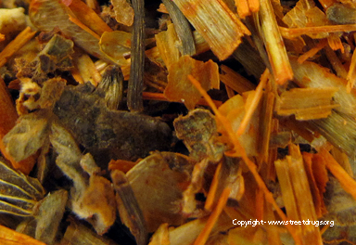
SPICE
• 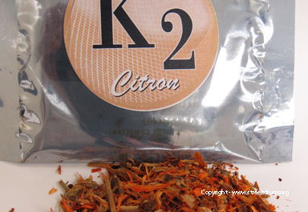
SPICE
• 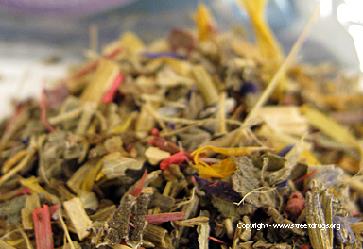
SPICE
• 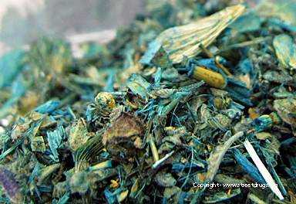
SPICE

K2 - SPICE
K2 or “Spice” is a mixture of herbs and spices that is typically sprayed with a synthetic compound chemically similar to THC, the psychoactive ingredients in marijuana. The chemical compounds typically include HU-210, HU-211, JWH-018, and JWH-073. K2 is commonly purchased in head shops, tobacco shops, various retail outlets, and over the Internet. It is often marketed as incense or “fake weed.” Purchasing over the Internet can be dangerous because it is not usually known where the products come from or what amount of chemical is on the organic material.
K2 is typically sold in small, silvery plastic bags of dried leaves and marketed as incense that can be smoked. It is said to resemble potpourri.
The Wyoming Department of Health was notified by Natrona County public health officials regarding three patients hospitalized for unexplained acute kidney injury (AKI), all of whom reported recent use of synthetic cannabinoids (SCs), sometimes referred to as "synthetic marijuana." SCs are designer drugs of abuse typically dissolved in a solvent, applied to dried plant material, and smoked as an alternative to marijuana. AKI has not been reported previously in users of SCs and might be associated with 1) a previously unrecognized toxicity, 2) a contaminant or a known nephrotoxin present in a single batch of drug, or 3) a new SC compound entering the market. After the Wyoming Department of Health launched an investigation and issued an alert, a total of 16 cases of AKI after SC use were reported in six states. Review of medical records, follow-up interviews with several patients, and laboratory analysis of product samples and clinical specimens were performed. The results of the investigation determined that no single SC brand or compound explained all 16 cases. Toxicologic analysis of product samples and clinical specimens (available from seven cases) identified a fluorinated SC previously unreported in synthetic marijuana products: (1-(5-fluoropentyl)-1H-indol-3-yl)(2,2,3,3-tetramethylcyclopropyl) methanone, also known as XLR-11, in four of five product samples and four of six patients' clinical specimens. Public health practitioners, poison center staff members, and clinicians should be aware of the potential for renal or other unusual toxicities in users of SC products and should ask about SC use in cases of unexplained AKI.

Source: CDC

Street Names:
• Bliss
• Black Mamba
• Bombay Blue
• Fake Weed
• Genie
• Spice
• Zohai
Streetdrugs.org

