STRESS: KNOW THE SIGNS

We all go through stressful times.
In small doses, stress may be good for you when it gives you a burst of energy. But too much stress or stress that lasts for a long time can take its toll on your body.
If you’re feeling overwhelmed by stress, you’re not alone. In fact a survey of Americans found that one-third of people are living with extreme stress.1 Get connected to how you’re feeling and learn about the effects of stress on your whole body.

Stress can be toxic to your body!
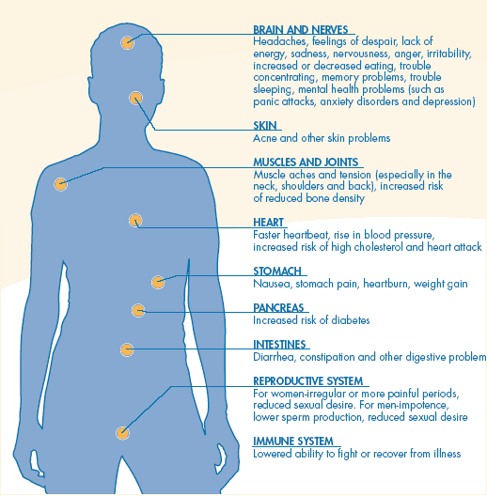

Are you experiencing the signs of stress?
- Feeling angry, irritable or easily frustrated
- Feeling overwhelmed
- Change in eating habits
- Problems concentrating
- Feeling nervous or anxious
- Trouble sleeping
- Problems with memory
- Feeling burned out from work
- Feeling that you can’t overcome difficulties in your life
- Having trouble functioning in your job or personal life
If you’re having any of these symptoms, it’s important that you take care of yourself. There are healthy steps you can take to stay well when you’re stressed, like connecting to people close to you, getting enough sleep or being physically active. Visitwww.LiveYourLifeWell.org for more information.
If you feel overwhelmed, unable to cope and feel as though your stress is affecting how you function every day, it could be something more, like depression or anxiety. Don’t let it go unchecked. Contact your health care provider.
© 2012 Mental Health America |

