Dartmouth College
COMMITTEE FOR THE PROTECTION OF HUMAN SUBJECTS
CPHS@Dartmouth.edu • 603-646-6482

CLOSURE FORM
Please complete: CPHS# PI:

INSTRUCTIONS: to create a request to terminate IRB review, start by logging into Rapport to create a new Continuing Review action. On the second screen, click the first four boxes under Research Milestones (see example below). If any of these first four boxes do not apply, the study is not eligible for closure, and should continue to receive CPHS review.
Study Closure Example (this is not an editable item):
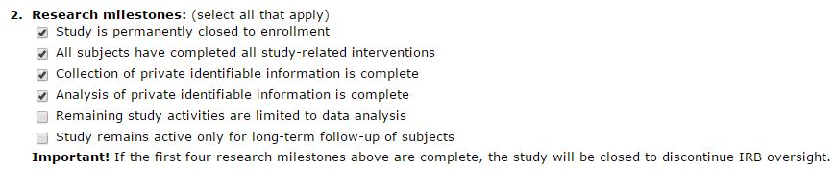

- Please provide information for each item not checked in question #4 of the Continuing Review page in Rapport:

- In reasonable detail, provide a synopsis of the study activities to date, both overall and at local sites. For example, is the study progressing as planned? If no formal progress report is available, please discuss any available interim study results, enrollment targets, reasons for funding changes, etc.

- Does the investigator hold information identifying each participant or any remaining specimens?

☐ No
☐ Yes

If yes, describe the method of storage or disposition here:

If yes, will you continue to analyze identifiable data?
☐ No
☐ Yes If yes, the study is not eligible for closure. Please submit a Continuing Review form.

Important Notes:
- Once a study is closed, it is the responsibility of the research team to maintain the confidentiality of the data.
- PHI (protected health information) or PII (personally identifiable information) may not be disclosed (released outside of Dartmouth) without appropriate institutional approvals. Contact the CPHS Office for further information.
- Contact the CPHS Office if you intend to use stored research data for a future research purpose other than that originally proposed.
- Please note any and all reliance agreements associated with the study will end with closure of the study.

Optional: Use the space below to provide a list of specific items to be named on the Closure letter:

